**Spree: Test Strategy**

1. **Introduction:**

**Spree is an E-commerce** (**electronic commerce**) application.This application involves the activity of electronically buying products on online services or over the Internet.

1. **Featured to be tested:**

* Easy login & registration
* User-friendly product filtering and sorting
* Detailed product descriptions
* Product gallery
* Shopping cart
* Shipping options
* Order summary
* Secure and easy in-app payments
* Ordering an invoice and adding company data

1. **Featured not in scope of current release:**

* Returns and checking the return status
* Checking the shipping status
* The number of items users are seeing/left on the list
* Checking item availability in specific locations
* Item availability reminder
* Wishlist

1. **Build Path to production**

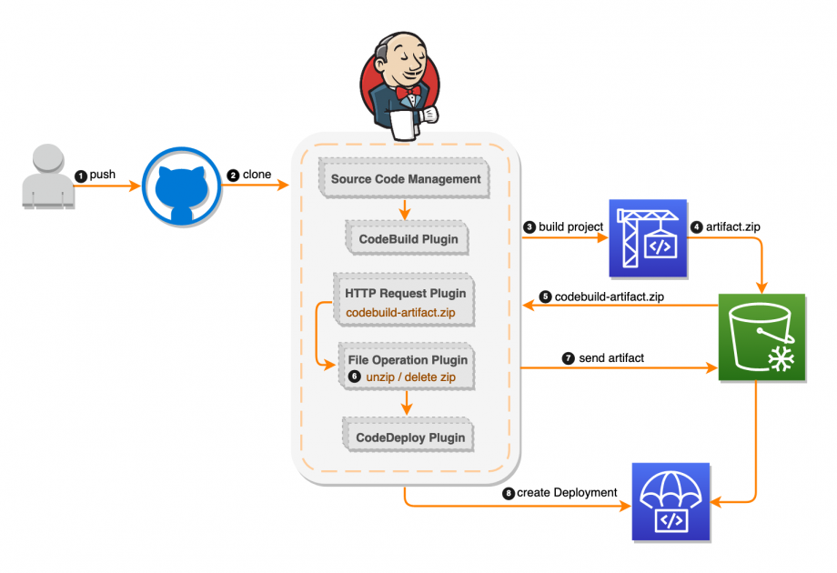

How tests fit into a software development pipeline. 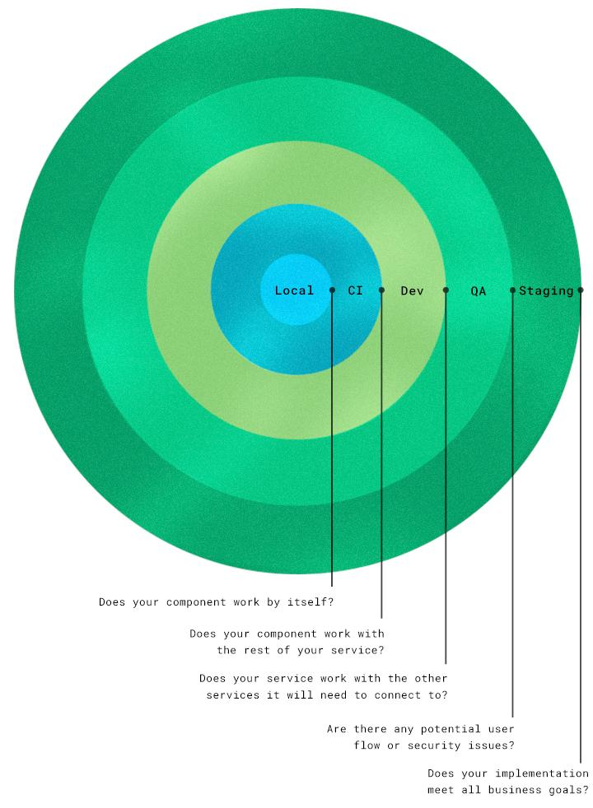

1. **Build Tasks**

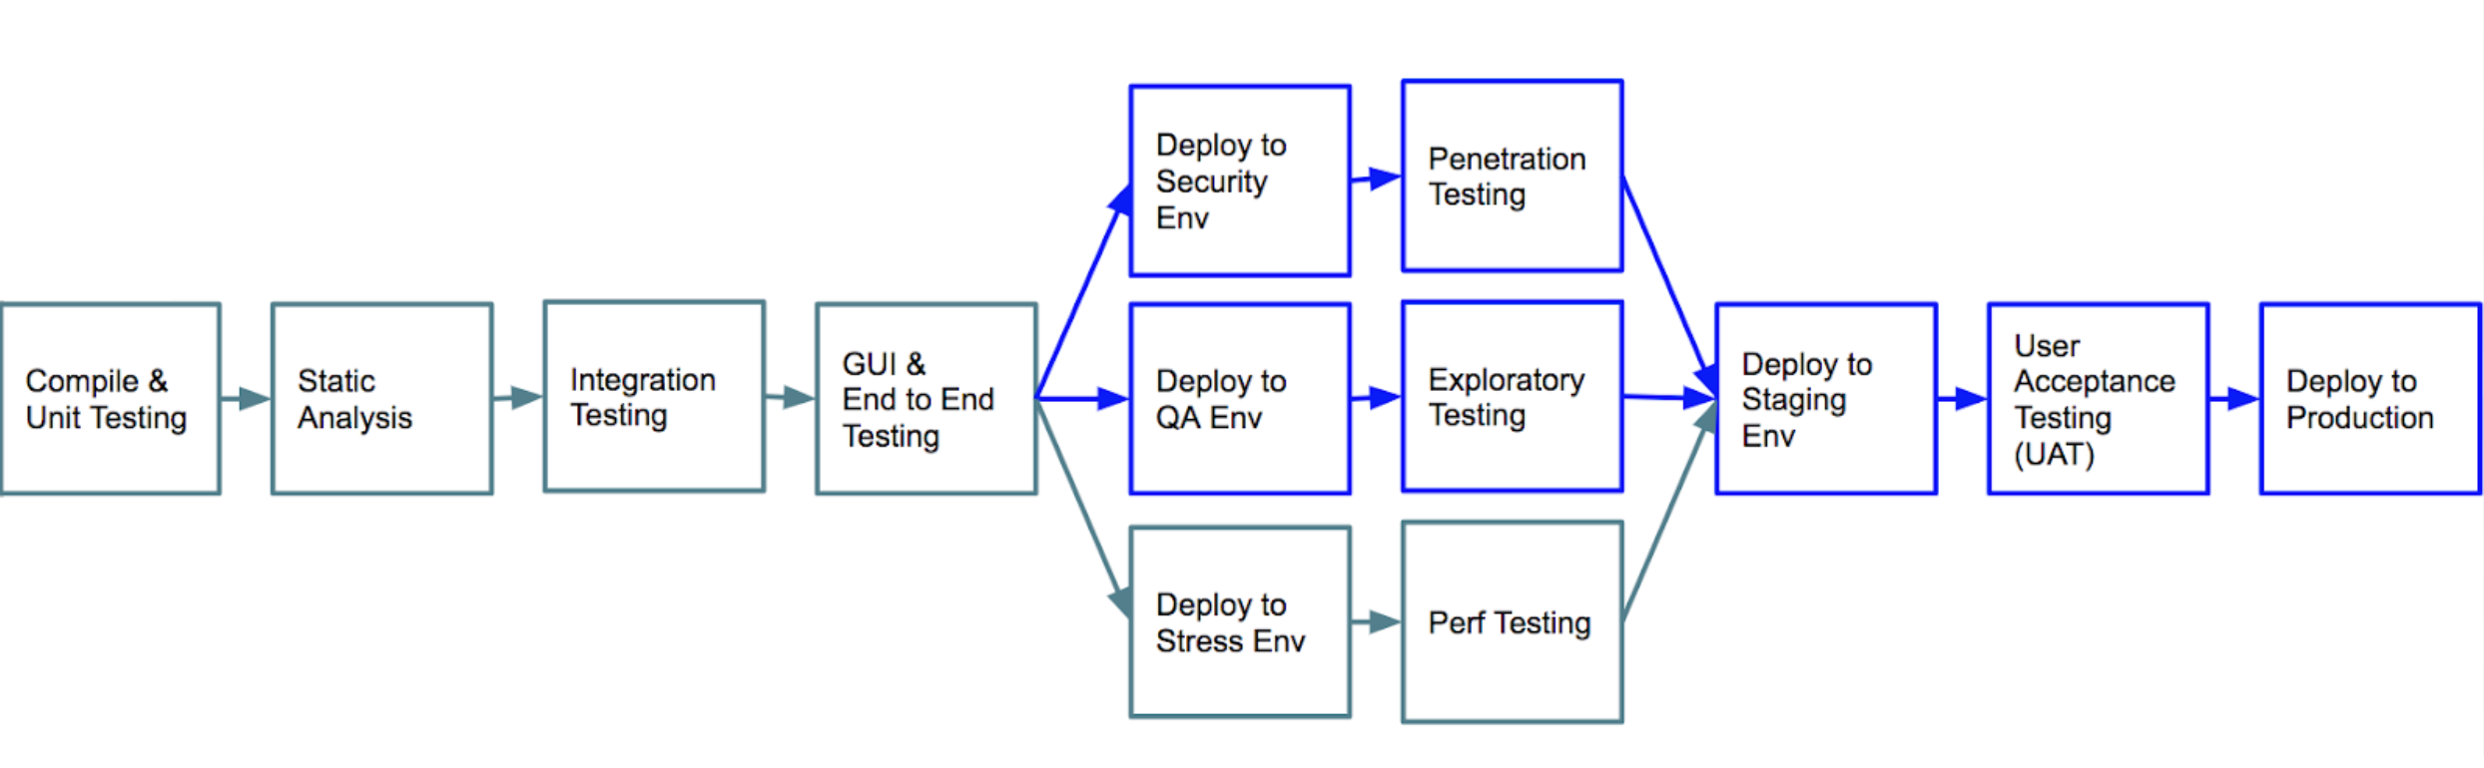

1. **Types of tests and Test Pyramid:**

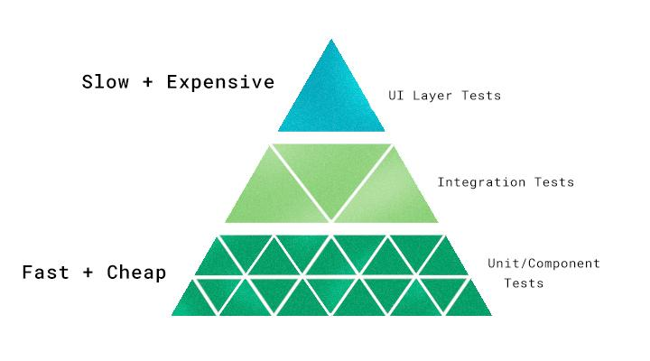

* **Unit/component test:** These cover the smallest possible components, units, or functionalities. They’re the cheapest and fastest tests to run since they don’t require a lot of dependencies or mocking. These should be done early to get them out of the way.
* **Integration test:** These check how well each unit from the previous stage works with the other components, units, and functionalities. In a broader sense, it can test how services (such as APIs) integrate with one another.
* **UI layer testing:** This is automated browser-based testing which tests basic user flow. It is expensive to set up and slow to run, so it should happen later in the pipeline.

## **Performance testing-** a top priority in Spree application.

1. **What are we not covering in tests:**

Security Testing

Infrastructure Testing

1. **Test Tools**

UI Automation: Selenium Webdriver,TestNG

CI: Jenkins

Configuration management and Version Control: GIT & GIThub

Performance Testing: JMeter

Test Management and Defect Tracking: QC

1. **Story Lifecycle:**

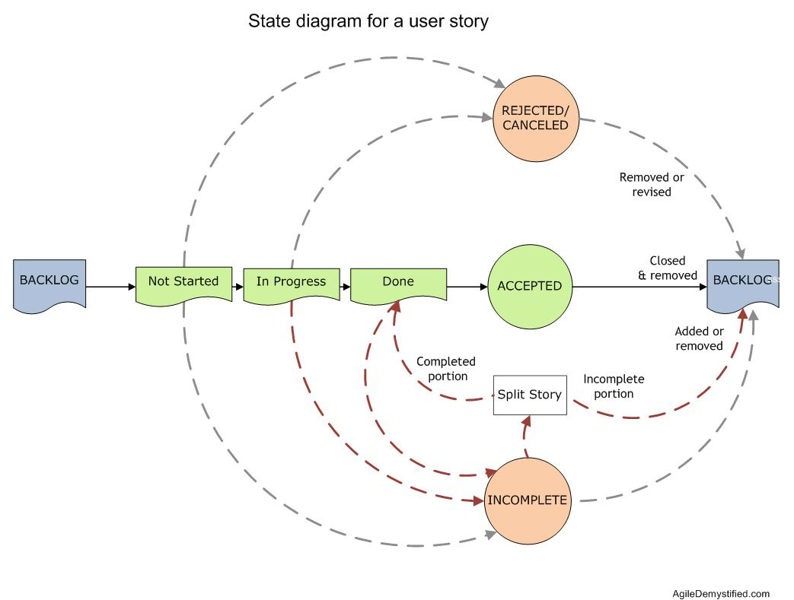

**10.Architecture level Strategy**

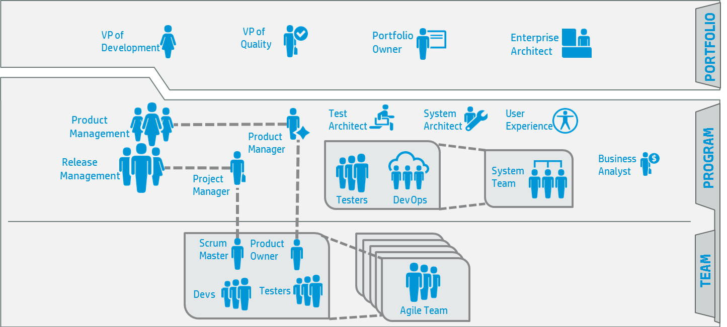

**11. Defect life cycle**

